PIZZA SALES SQL QUERIES

A.KPI’s

1.TOTAL REVENUE

SELECT SUM(total_price) AS TOTAL_REVENUE from pizza_sales

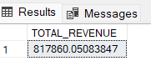

2.Average Order Value

SELECT * FROM pizza_sales

SELECT SUM(total_price) / COUNT(DISTINCT order_id) as Avg_Order from pizza_sales

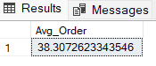

3.TOTAL PIZZA SOLD

SELECT SUM(quantity) AS Total_Pizza_Sold from pizza_sales

4.TOTAL ORDERS

SELECT COUNT(DISTINCT order_id) AS Total_orders from pizza_sales

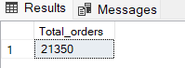

5.AVERAGE PIZZA PER ORDER

SELECT CAST(CAST(SUM(quantity) AS DECIMAL(10,2))/

CAST(COUNT (DISTINCT order_id) AS DECIMAL(10,2)) AS DECIMAL(10,2))from pizza_sales

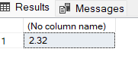

**-----PROBLEM STATEMENT------------**

**1.DAILY TREND FOR TOTAL ORDERS**

SELECT DATENAME(DW,order_date) as order_day, COUNT(DISTINCT order_id) AS Total_orders

from pizza_sales

GROUP BY DATENAME(DW, order_date)

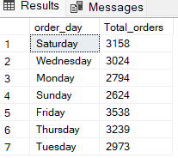

**2.HOURLY TREND FOR TOTAL ORDERS**

SELECT DATENAME(MONTH , order_date) AS Month_Name , COUNT(DISTINCT order_id) AS TOTAL_ORDERS

FROM pizza_sales

GROUP BY

DATENAME(MONTH , order_date)

ORDER BY Total_Orders DESC

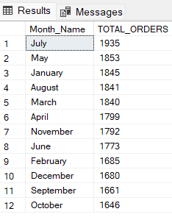

**3.PERCENTAGE OF SALES BY PIZZA CATEGORY**

SELECT pizza_category,sum(total_price) as Total_Sales ,sum(total_price)*100/

(SELECT sum(total_price)from pizza_sales WHERE MONTH(order_date) = 1)AS PCT

from pizza_sales

WHERE MONTH(order_date) = 1

GROUP BY pizza_category

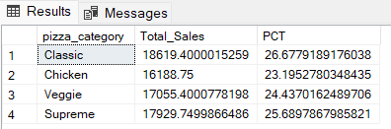

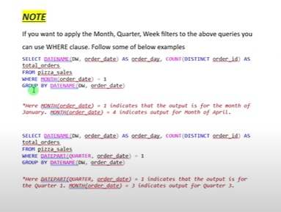

4.PERCENTAGE OF SALES BY PIZZA SIZE

SELECT pizza_size,CAST(sum(total_price) AS DECIMAL(10,2)) as Total_Sales ,CAST(sum(total_price)*100/

(SELECT sum(total_price)from pizza_sales WHERE DATEPART(quarter ,order_date)=1) AS DECIMAL(10,2)) AS PCT

from pizza_sales

WHERE DATEPART(quarter ,order_date)=1

GROUP BY pizza_size

ORDER BY PCT DESC

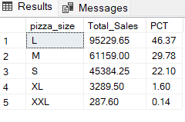

5.TOTAL PIZZAS SOLD BY PIZZA CATEGORY

SELECT pizza_category,SUM(quantity) as Total_Quantity_sold

FROM pizza_sales

WHERE MONTH(order_date)=2

GROUP BY pizza_category

ORDER BY Total_Quantity_sold DESC

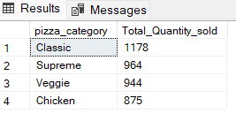

6.TOP 5 BEST SELLERS BY TOTAL PIZZAS SOLD

SELECT TOP 5 pizza_name, SUM(total_price) AS Total_Revenue FROM pizza_sales

GROUP BY pizza_name

ORDER BY Total_Revenue DESC

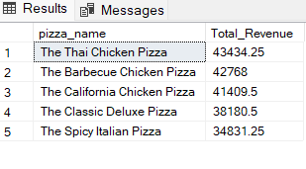

7.BOTTOM 5 WORST SELLERS BT TOTAL PIZZAS SOLD

SELECT TOP 5 pizza_name, SUM(total_price) AS Total_Revenue FROM pizza_sales

GROUP BY pizza_name

ORDER BY Total_Revenue

